

Student Name: Yanikepalli Sri Sekhar

Student Id Number: A000325769

Course: Masters in Data Analytics

Date: 07 April 2025

Project Title
A Comprehensive Analysis of Giant Bicycles' Sales, Profit, and Manufacturing Performance

Contents
Introduction 3
Project Overview 3
Aim of the project 4
Project Components: 4
Dataset Selection 4
Data Preparation 4
Exploratory Data Analysis (EDA) 4
Data Visualization 5
Ethical Issues 16
Conclusion 16
Appendix A: Snapshot of the raw data (first five rows) and a snapshot of the data ready for analysis 17
Appendix B: Data dictionary 17
Summary 18
References 19

Introduction
Data visualisation is an effective method for assessing and analysing data gathered from specific companies or services. Determining suitable visualisation methods for analysing specific data on different production segments is important. The present context of the research focuses on the manufacturing industry and some specific data has been collected from different sources to develop suitable visualisations.
Giant Bicycles (GB) is one of the largest bicycle manufacturers and it operates in countries like Germany, Canada, France, Mexico, and the USA (Giant Bicycles, 2023). The company has provided some data on the different types of bicycles like Amarilla, Carretera, Montana, Paseo, Velo, and VTT (Giant Bicycles, 2023). These data include several factors of manufacturing like Manufacturing Price, Gross Sales, Discount, Sales, COGS, Profit, and Date of Purchase. The company is willing to determine valuable insights into the data and develop relevant strategies according to the findings. The focus of the company is to analyse their previous sales and other factors which are subject to impact their performance in the market. In order to improve their methods and approaches to determine strategy the present visualization and analysis methods are to be applied.
The goal of the research is to process the data gathered and answer some predetermined questions to address the requirements of the company. It is important for the research to process the data effectively and deliver the required performance measures of the company to fulfil the arguments and development of the company.

Project Overview
The project has been developed to design some suitable Tableau worksheets that implement some comprehensive visualisations. These visualisations are subjected to focus on specific areas of the data to gather insights from the data (Lavanya et al. 2023). These insights include the performance measures of the company in terms of selling different products they have developed. In order to develop such visualization and relevant dashboard in the Tableau worksheet the data must be properly cleaned (Beard and Aghassibake, 2021). The process for developing such visualisations includes extracting the data from the source file, transforming the data, and loading the data in the Tableau platform. After loading the data on the platform, some parameters and calculated fields must be implemented.
In the present context of the analysis report, the data must be used properly to determine the sales and other growth factors for depicting the efficiency of the organisation. The sales and other growth factors can also be backed up with the evidence of manufacturing costs. This is essential in order to determine the efficiency of the company in implementing strategies. Motivating factors can also be determined using the discount of the sales in different periods. Such insights are required to be addressed in order to deliver ideas for the company to develop strategies in the competitive market.

Aim of the project
"To analyse global sales and profitability trends across product segments and countries, enabling data-driven decisions to optimize pricing, discounts, and market strategies."
This project delivers that, to transform raw sales data into actionable insights through interactive visualizations. The dashboard provides senior management with a dynamic tool to explore profitability, sales trends, and the impact of discounts across different markets by using Tableau tool.

Project Components:

Dataset Selection
The details of the dataset can be found in the data dictionary together with the snapshot of the data for the first five rows in the appendices. The selection of the data set can be effectively justified as the company selected has markets in the countries that are available in the data set and also the products sold by this company are available in the data set.

Data Preparation
The data has been prepared for visual representation and the presence of different aspects like products and sales manufacturing cost COGS date of the sales are helpful in driving different aspects of the marketing. In order to derive better prospects from the data the data has been cleaned properly by removing null values and other ineffective attributes which can hamper the process of visualization through Tableau workbook.

Exploratory Data Analysis (EDA)
The following representations of graphical measures and the dashboard enable the company to derive conclusions based on their previous performance. In order to develop better Strategies for better marketing the development of an effective graphical representation of the previous performance is essential.

Data Visualization
Chart - 1
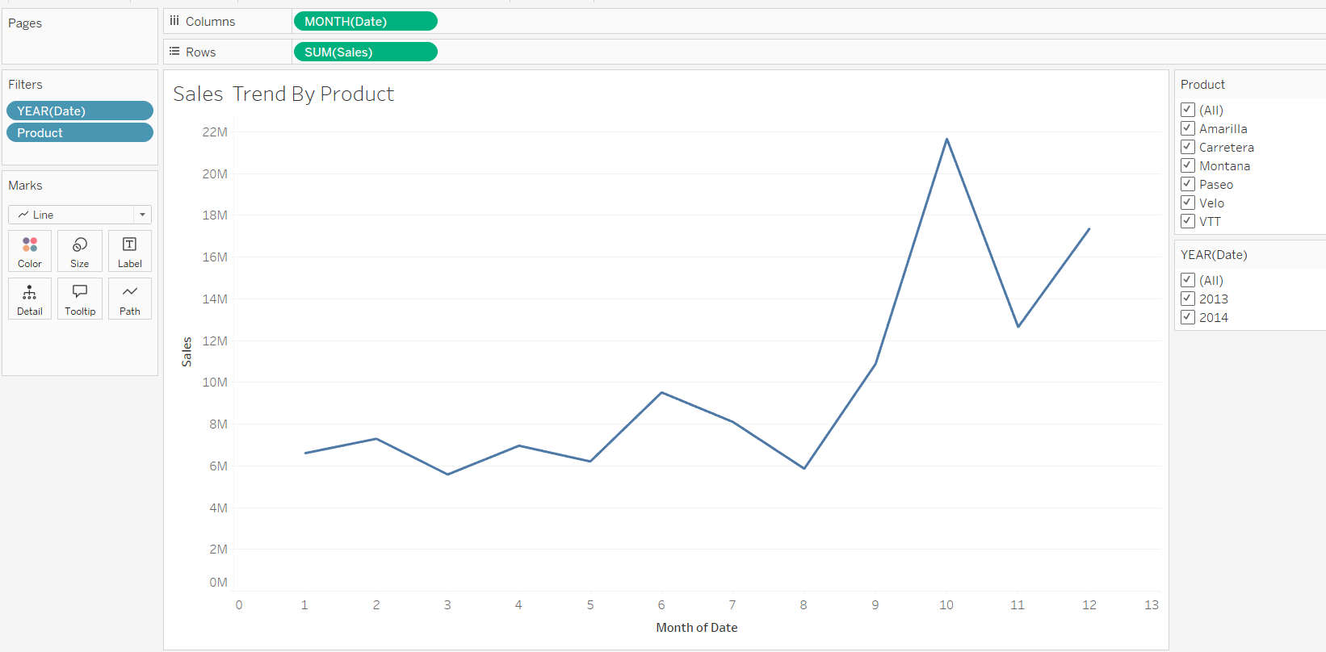

Figure 1: Sales Trend by Product
The Sales Trend by Product line chart giving us a critical analytical tool for understanding the sales performance of various products over time. The primary purpose of this chart is to reveal patterns, seasonal trends, and comparative performance across different product lines. By visualizing monthly sales data from September 2013 to December 2014, this line chart enables stakeholders to identify which products in the manufacturing company are driving revenue, which are underperforming, and how external factors such as seasonality impact sales. The interactive filtering feature allows users to isolate specific products, making it easier to conduct targeted analysis and support data-driven decision-making in areas such as inventory management, marketing strategies, improving in sales, and pricing adjustments.
The main key observation from this line chart is that varying performance across products. For example, Montana demonstrates consistently high sales, suggesting strong market demand and potential for further investment. In contrast, Paseo shows very low sales, indicating a need for strategic reassessment - whether through promotional efforts, or discontinuation. This seasonal trends are also evident, particularly for VTT, which experiences significant sales spikes and highlighting opportunities for timed marketing campaigns.

This visualization is particularly valuable for sales and marketing teams, as it helps pinpoint which products require attention. For example Montana is high performing product and Paseo is
very low performing product.

The main reason to choose this line chart is that, its effectiveness in displaying trends over time, making it ideal for time-series analysis. Unlike bar charts, which can become cluttered with multiple products, the line format provides clarity and facilitates easy comparison. The interactivity further enhances usability, allowing stakeholders to modify the view based on their analytical needs.
In summary, this line chart is a powerful tool for transforming raw sales data into actionable business intelligence, driving strategic decisions that enhance profitability and operational efficiency.

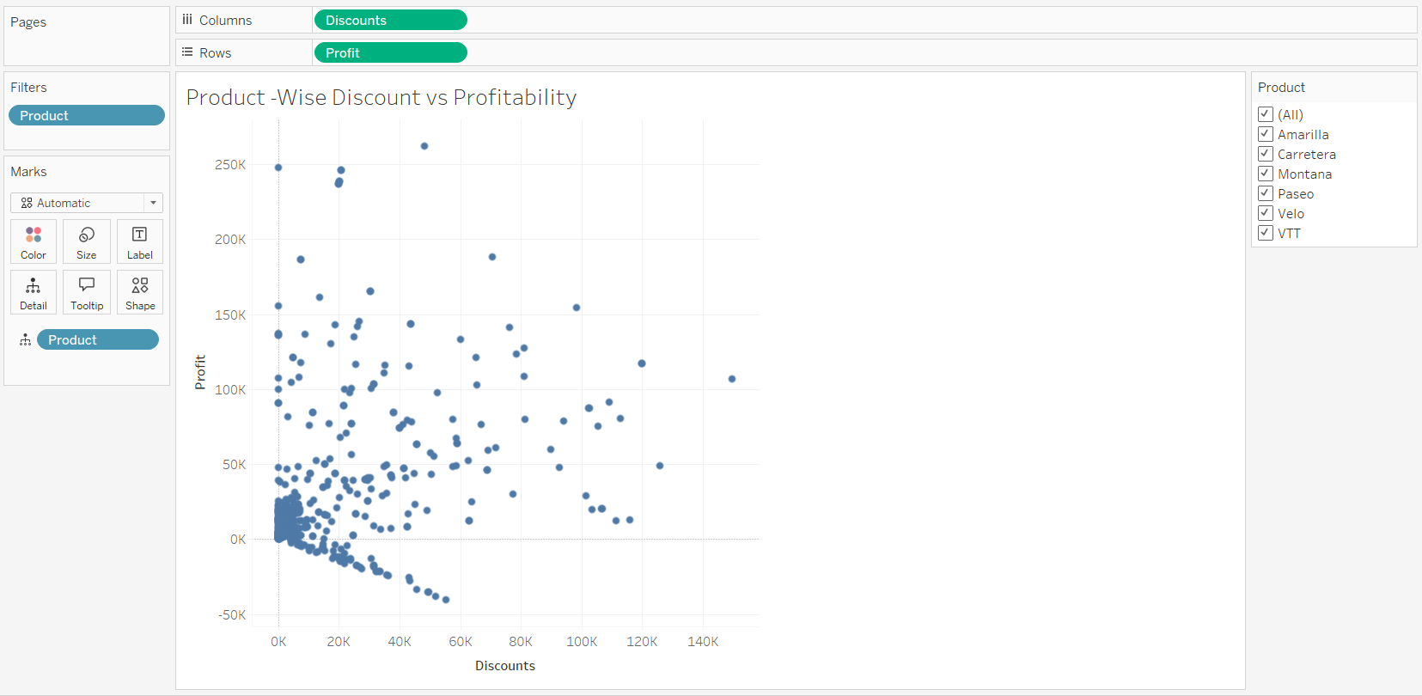
Chart -2

Figure 2: Product – Wise Discount vs Profitability
The Product-Wise Discount vs Profitability scatterplot chart is designed to analyse the relationship between discount strategies and their impact on the profitability of different products. By scattering discounts against profit margins, this visualization helps businesses identify whether offering discounts on specific products leads to increased sales volume at the expense of profitability or if it drives sustainable revenue growth. The scatterplot chart serves as a strategic tool for pricing optimization, enabling stakeholders to determine the ideal discount levels that balance customer attraction with profit retention.
The main Key observations from this scatterplot chart are High-discount products like Paseo or Velo may show lower profitability, suggesting that excessive discounts will reduce the margins and despite higher sales volume. Low-discount products like Montana or Carretera often maintain strong profitability, indicating that these items may not require any aggressive pricing strategies to perform well. And Negative profitability for some products at certain discount levels highlights the risks of over-discounting, where the cost of promotions is not able to help to the revenue to gain any revenue.
This scatterplot visualization is particularly valuable for pricing and sales teams, as it provides actionable insights into how discounts influence the bottom line. For instance those products with low or negative profitability must need some discount strategies, the products with high profitability could sustain minimal discount, preserving profitability while attracting customers, and low profitability products might benefit from targeted discounts to clear inventory without harming the annual profits.
The interactive filtering feature in this chart allows users to isolate specific products, making it easier to tailor strategies for each item. For example, selecting "Amerilla" might reveal that moderate discounts yield the best balance between sales growth and profit retention, while "Paseo" might show that discounts are ineffective.
This scatter plot chart is ideal for this analysis because it clearly displays the correlation between two variables - discounts and profitability. The visual representation of data points makes it easy to spot outliers, trends, and clusters, enabling quick decision-making.
In summary, this scatterplot chart empowers businesses to refine their discount strategies, ensuring they maximize profitability while remaining competitive in the market. After getting these insights, companies can make data-driven decisions that enhance both revenue and operational efficiency.

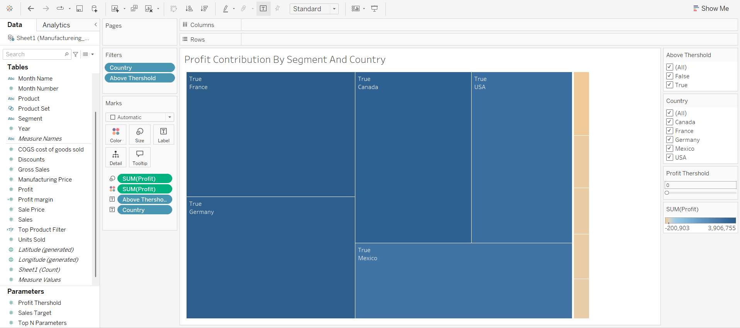
Chart -3

Figure 3: Profit Contribution by Segment and Country
This tree maps visualization serves as a strategic profitability analysis tool that examines how different customer segments contribute to profits across various countries. The primary goal is to identify high-performing market segments and geographic regions while detecting underperforming areas that may require strategic intervention. By analysing profit distribution at this level, businesses can make informed decisions about resource allocation, market expansion, and segment-specific sales strategies. companies to determine that what strategies they should apply in the future for making their performance better in the market.
The tree maps chart appears to use a combination of filtering mechanisms and data dimensions to analyse profit contributions. Some key components include:
Segment in Filter section Allows isolation of specific customer categories (Government, Channel Partners, Enterprises, etc.)
Country in Filter section Enables geographic comparison of profitability (Canada, France, Germany, Mexico, USA)
Profit Threshold is a newly created Parameter that will help us to Sets a benchmark to highlight areas exceeding target profitability levels
The Main Purpose of this tree maps analysis provides actionable insights for sales and marketing leadership. The combination of dimensional filtering with newly created threshold parameters creates a powerful tool because the created tree maps contains:
1.Multi - dimensional analysis which helps user examines the segment, country and time dimensions simultaneously.
2.Performance Benchmarking for this the threshold parameter provides clear performance standards.
3.Filters allow users to explore the data from multiple perspective.
This visualization converts raw financial data into strategic insights, allowing for data-driven decisions on market focus and resource allocation. Organizations can improve their financial performance by identifying where and with whom profits originate.

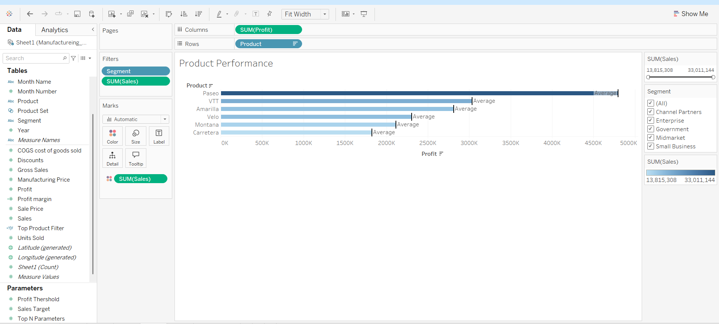
Chart -4

Figure 4: Product Performance
The Product Performance bullet graph provides a comprehensive overview of sales and profitability metrics across different product lines. The main purpose of this bullet graph is Compare product performance by analysing key financial metrics (sales, profit, costs), Identify high-value products that contribute most to revenue and profitability, Support strategic decision-making regarding product focus, pricing, and inventory management and Enable segment-based analysis to understand how different customer groups interact with products
The bullet graph combines tabular data with interactive filtering to allow stakeholders to drill down into specific products, segments, or time periods for targeted insights.
Each product's performance is evaluated against averages, making it easy to spot outliers.
For instance: Montana appears to be a top performer based on the sales scale (up to $500K).
Velo and Carretera may need further analysis if they show lower-than-average profitability.
The bullet graph has various interactive elements such as:
Segment filter (Government, Enterprise, Small Business, etc.): Users can analyze how different customer types purchase each product.
The bullet graph has various parameters such as:
Profit Threshold: Highlights products that exceed goal profitability.
Sales Target: Flags products that full fill revenue goals.
Top N Parameters: Concentrates investigation on the top-performing products.
The bullet graph has various Key metrics such as:
The data emphasized:
Gross Sales vs Profit Margin: Some products may have great sales but low profitability (for example, due to discounts or high manufacturing costs).
Units Sold: Helps separate high-volume/low-margin products from low-volume/high-margin products.
Businesses may improve their product portfolio, pricing policies, and segment-specific marketing initiatives by using this Bullet graph, which converts raw sales data into actionable information. It functions as a potent instrument for data-driven decision-making by fusing flexible filtering with detailed product metrics.

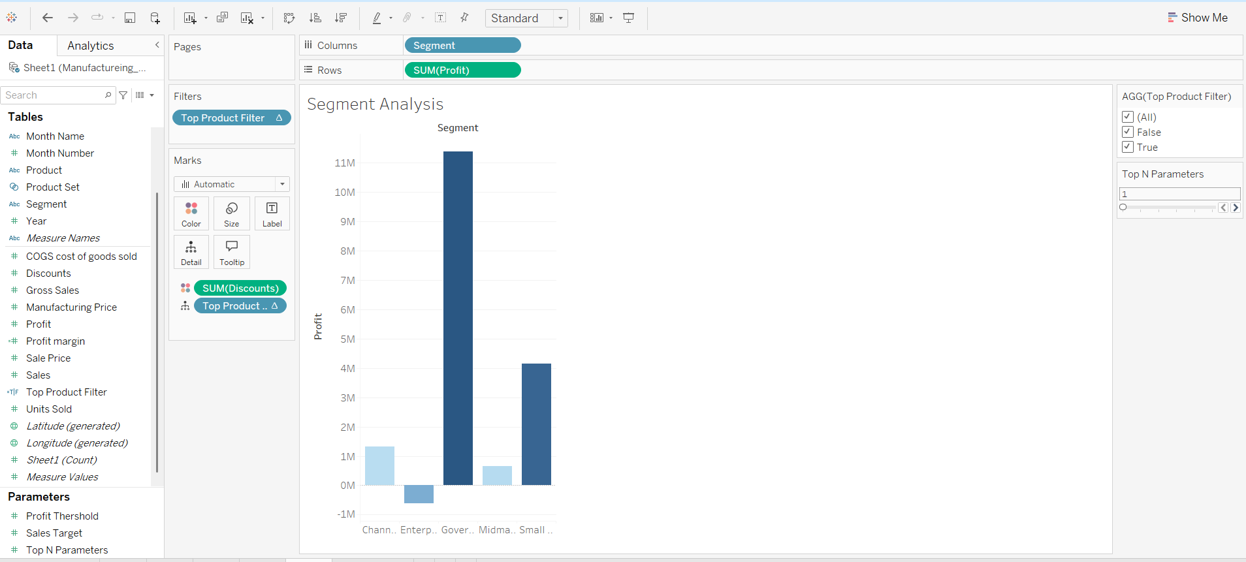
Chart -5

Figure 5: Segment Analysis
The Segment Analysis stacked bars presents about the total profit for every client segment in the manufacturing dataset is displayed in this Tableau Segment Analysis bar chart. Channel Partners, Enterprise, Government, Midmarket, and Small Business are the five client segments that make up the x-axis.
The entire profit made from each segment is shown on the y-axis. As indicated by the presence of SUM(Discounts) in the colour mark, the chart employs colour intensity to convey an additional measure, most likely the discount amount.
The filters used here are quite important. The Top N Parameters slider controls the Top Product Filter parameter used in the display. Using a user-defined statistic, such sales or profit, this configuration restricts the data to the top N goods.
Only top-performing products (based on user choices) are included in the segment analysis since the filter is configured to display only those entries where Top Product Filter = True. Dynamic analysis based on product performance is made possible by this interaction.
We may use this graph to see which customer segments are making the most money off of the top N goods. For instance, the Government section displays a negative figure, suggesting a loss, whereas the Enterprise segment is contributing the biggest profit. Business initiatives, such as where to enhance product focus or modify price and discounts, might be informed by this data. This chart is perfect for decision-making dashboards since it can be used as an interactive performance analysis tool instead of just a static depiction by utilizing parameters and calculated variables.

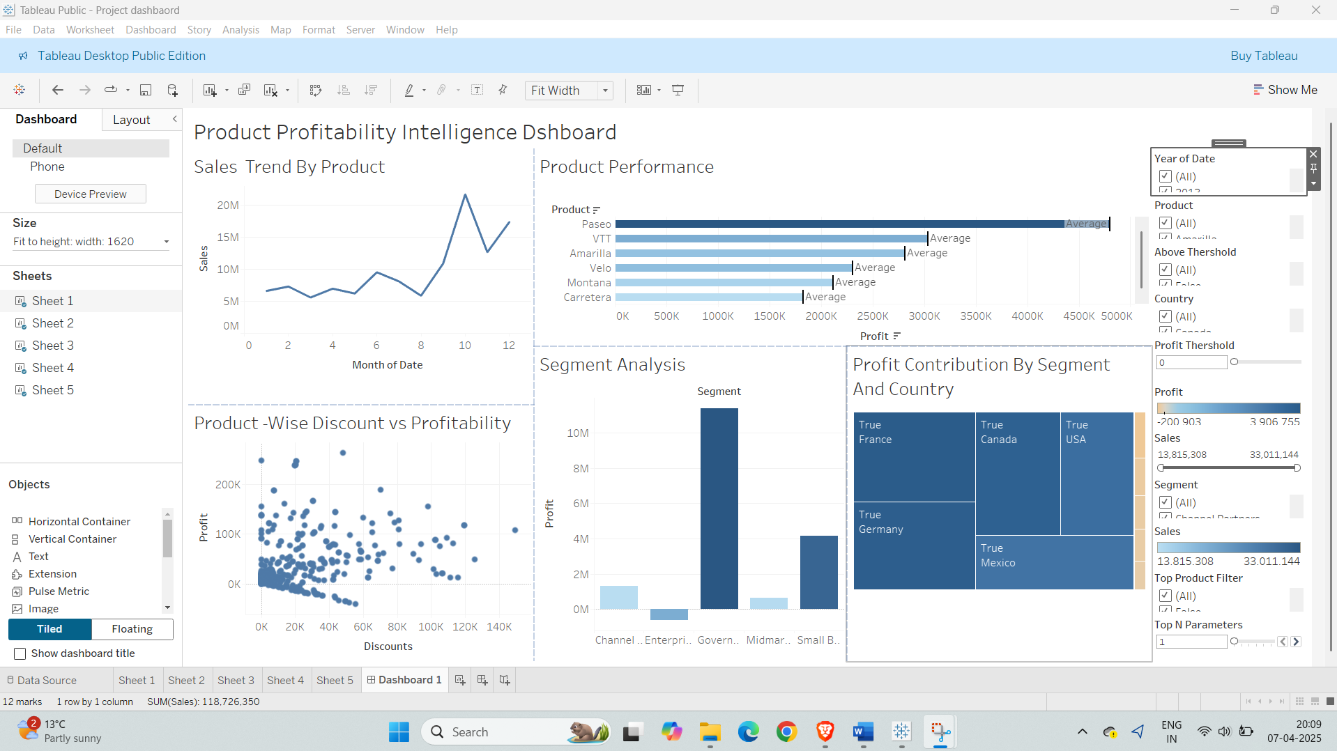
Dashboard

Figure 6: Product Profitability intelligence Dashboard
A thorough Tableau dashboard, this Product Profitability Intelligence Dashboard examines the sales, discounts, and profitability of various products, markets, and nations. With the help of filters and parameters, it integrates several visualizations to present a comprehensive picture of important performance indicators.
The Sales Trend by Product line chart, located at the upper left, illustrates the monthly variations in total sales. It is simple to monitor performance throughout the year with this representation, which enables users to see monthly sales spikes or seasonal patterns.
The Product Performance horizontal bar chart, which shows the total profit per product next to it, also includes an average line for comparison.
This makes it easy for customers to discover whether products are doing better or worse than average.
Additional diagnostic and comparative visualizations can be found in the dashboard's lower section. The relationship between each product's discounts and profitability is displayed in the Product-Wise Discount vs. Profitability scatter plot (bottom left). This is especially helpful for determining if larger discounts result in higher or worse profitability, which is crucial for decisions on pricing and promotions.
The Segment Analysis bar chart helps stakeholders understand which company segments are most valuable by showing the total profit for each client segment at the middle-bottom.
The Profit Contribution by Segment and Country tree maps, which provides a comparative size-based perspective, breaks down the total profit geographically and by segment on the right. Higher profits are shown by larger blocks, which makes distribution easier to see at a glance. Interactive filters and parameters, including year, product, country, profit threshold, and top product filters, are included with all of these charts to enable the user to conduct dynamic drill-downs and what-if analyses. For scenario analysis, the Profit Threshold slider is particularly useful because it allows users to set a target profit level and filter the view appropriately.
In conclusion, this dashboard supports strategic business decisions by combining segmentation, performance tracking, and what-if simulation. With the help of robust interaction, it progresses from broad patterns to detailed product and segment-level data.

Ethical Issues
The ethical issues faced in developing a suitable visualisation are related to data protection. In order to develop suitable measures for the company, financial and sales data have been gathered which need to be stored in a secure database (Pammer-Schindler and Rosé, 2022). In terms of developing effective security for the database password protected files have been created. One of the Other ethical considerations was to not disclose the data or use the data for different purposes than the development of visual representation. All the ethical standards have been properly followed throughout the development and processing of data.

Conclusion
Conclusively, the data representation with the graphical and dashboard creation has been helpful in determining the company's sales and profit-related performance. Giant Bicycles is the company for which the visual representation has been developed and using different filter functions and other suitable representations an effective dashboard has been created which is interactive. The results show that the company must develop effective strategies to meet the requirements of the market for the betterment of its performance in the future. In order to develop suitable strategies, representation has been helpful in identifying the time segment and product gaps in resourcing and other mistakes. The recommendation for the company is to increase sales by improving the manufacturing cost in different countries where the company operates.

Appendices

Appendix A: Snapshot of the raw data (first five rows) and a snapshot of the data ready for analysis
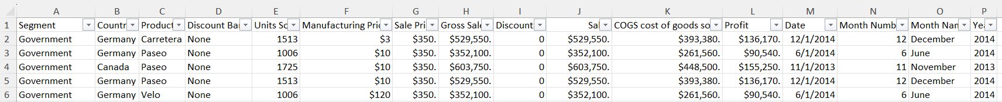

Appendix B: Data dictionary
Variable | Values | Type | Description
Segment | Governments, Channel Partners, Enterprises, Midmarket, and Small Businesses | String | Market Segments
Country | Germany, Canada, France, Mexico, and the USA | String | Countries where the company operates
Product | Amarilla, Carretera, Montana, Paseo, Velo, and VTT | String | Products that the company sells
Discount Band | High, Low, Medium, None | String | Segregation of Discounts
Units Sold | No. Of Units Sold | Numeric (Integer) | Number of Units of Sold Product
Manufacturing Price | Price at Manufacturing company | Numeric (Dollar) | Manufacturing Price of Sold Product
Sale Price | Price of the product after manufacturing | Numeric (Float) | Sale Price of Sold Product
Gross Sales | Values between $3 - $260 | Numeric (Dollar) | Gross Sales of Sold Product
Discounts | 0 – 11,500 | Numeric (Float) | Discounts of Sold Product
Sales | $1000 - $1200000 | Numeric (Dollar) | Sales of Sold Product
COGS cost of goods sold | $1000 - $1200000 | Numeric (Dollar) | COGS cost of goods sold of Sold Product
Profit | $50000 - $200000 | Numeric (Dollar) | Profit of Sold Product
Date | - - 05- 2013 to  31 - 12 - 2014 | Date | Date of Sale
Month Number | 5 - 12 | Numeric (Integer) | Month Number of Sale
Month Name | January, February, March, April, May, June, July, August, September, October, November, and December | String | Month Name of Sale
Year | 2013, 2014 | Numeric (Integer) | Year of Sale

Summary
The Product Profitability Intelligence Dashboard uses several interactive Tableau visualizations to give a thorough picture of product performance. In order to help spot seasonal spikes and dips in sales activity, it includes a line chart that displays the monthly Sales Trend by Product. Each product's profit is compared to an average reference line for benchmarking purposes in the Product Performance horizontal bar chart. This enables consumers to easily discern between products that work well and those that don't. A crucial finding for pricing strategy is that large discounts don't always translate into increased profits, as demonstrated by the scatter plot Product-Wise Discount vs. Profitability, which also examines the link between discounts given and profits made.
Additionally, the dashboard delves into geographic performance and client segmentation. In order to help with market targeting tactics, the Segment Analysis bar chart shows which client segments—such as Government, Small Business, etc.—produce the maximum profit. A visual breakdown of earnings by nation and section is provided by the Profit Contribution by section and nation tree maps, which highlights the most profitable locations (such as the USA and France). The dashboard's enhanced features, which include Product, Country, Year, and Segment filters as well as interactive options like Profit Threshold and Top N Parameters, enable users to focus on important profit drivers and conduct what-if studies for improved decision-making.

References
Batt, S., Grealis, T., Harmon, O. and Tomolonis, P., 2020. Learning Tableau: A data visualization tool. the Journal of economic education, 51(3-4), pp.317-328. DOI: https://doi.org/10.1080/00220485.2020.1804503
Beard, L. and Aghassibake, N., 2021. Tableau (version 2020.3). Journal of the Medical Library Association: JMLA, 109(1), p.159. DOI: https://doi.org/10.5195/jmla.2021.1135
Giant Bicycles, 2023. Giant Bicycles | USA – The world’s best bicycles & cycling gear. [online] Available at: https://www.giant-bicycles.com/us [Accessed 18 Mar. 2025].
Lavanya, A., Sindhuja, S., Gaurav, L. and Ali, W., 2023. A comprehensive review of data visualization tools: features, strengths, and weaknesses. Int. J. Comput. Eng. Res. Trends, 10(01), pp.10-20. DOI: https://doi.org/10.22362/ijcert/2023/v10/i01/v10i0102
Pammer-Schindler, V. and Rosé, C., 2022. Data-related ethics issues in technologies for informal professional learning. International Journal of Artificial Intelligence in Education, 32(3), pp.609-635. DOI: https://doi.org/10.1007/s40593-021-00259-x
Parhusip, H.A., Trihandaru, S., Heriadi, A.H., Santosa, P.P. and Puspasari, M.D., 2022. Data Exploration Using Tableau and Principal Component Analysis. JOIV: International Journal on Informatics Visualization, 6(4), pp.911-920. DOI: https://dx.doi.org/10.30630/joiv.6.4.952

